# PASSWORD BASED GARAGE DOOR

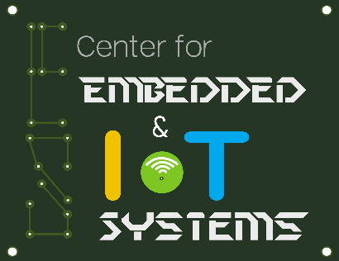

A project report submitted in partial fulfilment of requirement for the course

On

## Fundamentals of IoT

By

**GUNDETI SHIVA SAI (2003A51182)**

**KASAM GOUTHAM REDDY (2003A51150)**

**NUNAVATH VIVEK NAIK (2003A51188)**

**SAMBARAJU BENJAMIN (2003A51213)**

Under the guidance of

## Mr.Rajeshwarrao Arabelli

Asst.Prof.& Director Centre for Embedded Systems and IoT

Department of Electronics and Communication Engineering



# PASSWORD BASED GARAGE DOOR



A project report submitted in partial fulfillment of requirement for the course

On

## Internet of Things

By

**GUNDETI SHIVA SAI (2003A51182)**

**KASAM GOUTHAM REDDY (2003A51150)**

**NUNAVATH VIVEK NAIK (2003A51188)**

**SAMBARAJU BENJAMIN (2003A51213)**

Under the guidance

of

## Dr.Sumit Gupta

Asst.Prof.

Department of Electronics and Communication Engineering



**Center for Embedded Systems and Internet of things**

**SR UNIVERSITY**

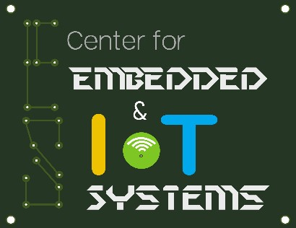

**CERTIFICATE**

This is to certify that the course project entitled **“PASSWORD BASED GARAGE DOOR”** is the bonafied work carried out by **GUNDETI SHIVA SAI(2003A51182) ,KASAM GOUTHAM REDDY(2003A51150),NUNAVATH VIVEK NAIK(2003A51188), SAMBARAJU BENJAMIN(2003A51213).**  In the partial fulfillment of the requirement for the award of course Internet of Things during the academic year 2022-2023 under our guidance and Supervision.

**Dr.SumitGuptha**

Asst.Prof.

Department of ECE

# ABSTRACT

Now a day’s most of the systems are automated in order to face new challenges and present day requirements to achieve good results. Automated systems have less manual operations so that the flexibility, reliabilities are high and accurate. Hence every field prefers automated control systems, especially in the field of electronics. The goal of the project is to develop a unique system through mobile technology which can control garage door. Just by enter password as a message we can do open/close operations on the garage door. The project also exhibits low cost home security system which is widely employed in our daily life. This system is designed to prevent the opening of the Garage door by unauthorized persons, the password entry system to open/close the door. As soon as the user enters the correct password, thedoor lock opens. The Basic requirement of security can be achieved by designing electrical or mechanical locks that are designed with one or a few key Basically traditional locks are heavy and are not protective as they can be broken down easily by using some tools. [Electronic locking systems](http://www.elprocus.com/password-based-electronic-lock-system/) are preferable over mechanical locks, to resolve the security problems that are associated with the mechanical locks This system uses Android technology for opening and closing operations. Hence, users can use their Android mobiles for door operations instead of using a keypad.

**CONTENTS**

**Chapter No. Title Page No.**

**1 Introduction 1**

**2 System Description 2**

**2.1 Block Diagram 2**

**3 Hardware & Software Tools 3**

**4 Implementation 9**

**4 Results 10**

**5 Conclusion 11**

**References 12**

# INTRODUCTION

This project is designed to unlock a garage door with an Android device by entering a single password in an Android application. An Android OS-based device, such as a mobile or tablet, is connected to this system through a Bluetooth device. The Bluetooth device is attached to the microcontroller, which is programmed with a particular password for opening and closing the garage door by its owner. An android application with a Graphical User Interface based touch screen

Whenever vechile comes near to the garage door the micro controller send a message to owner’s device the owner is asked to enter the password .After entering the password in the Android mobile, it sends that data to the microcontroller via its Wifi. With the stored password in the microcontroller, it compares and sends the control signals to the relay driver only if the two passwords match.

Then, relay performs mechanical operations to open and close the door through the motor, but in this project – the motor is replaced with the servo motor for a better usage. In this project, a micro servo is used in place of a motor for visualization purpose. After opening the door, the motor automatically closes the door with a predefined time setting on microcontroller for the reverse rotation of the servomotor.

**Problem statement:**

Basically traditional locks are heavy and are not protective as they can be broken down easily by using some tools. [Electronic locking systems](http://www.elprocus.com/password-based-electronic-lock-system/) are preferable over mechanical locks, to resolve the security problems that are associated with the mechanical locks

# SYSTEM DESCRIPTION

This is a simple project made with the ESP32. The aim is to control a Garage door lock without keys, and using a smartphone to accomplish this. The communication medium will be the internet (**WiFi module-ESP33**). This is one of the **simplest method to use ESP-3266.**All we need is an ultrasonic sensor, IR sensor, and a couple of basic apparatus which are easy to use and budget friendly. A IR sensors is going to be connected to an ESP32 board this detects the arrival of the car and it will close off at the Garage door which is attached with Micro servo, here we are using Ultrasonic sensor to detect the arrival of the car near the garage door. We have connected ultrasonic sensor trig pin to 25pin and echo pin to 26 pin and we have connected 2 IR sensor at pin number 35. And a micro servo to pin 17. whenever car arrives near the garage door it send the msg to the user via telegram bot ask the user to send the password. if passwords match it allows the micro servo to open the door .the will be enter into the garage and parked at any given slot . then esp32 will send the message to user as the car has parked at the parked slot.

**2.1BLOCK DIAGRAM**

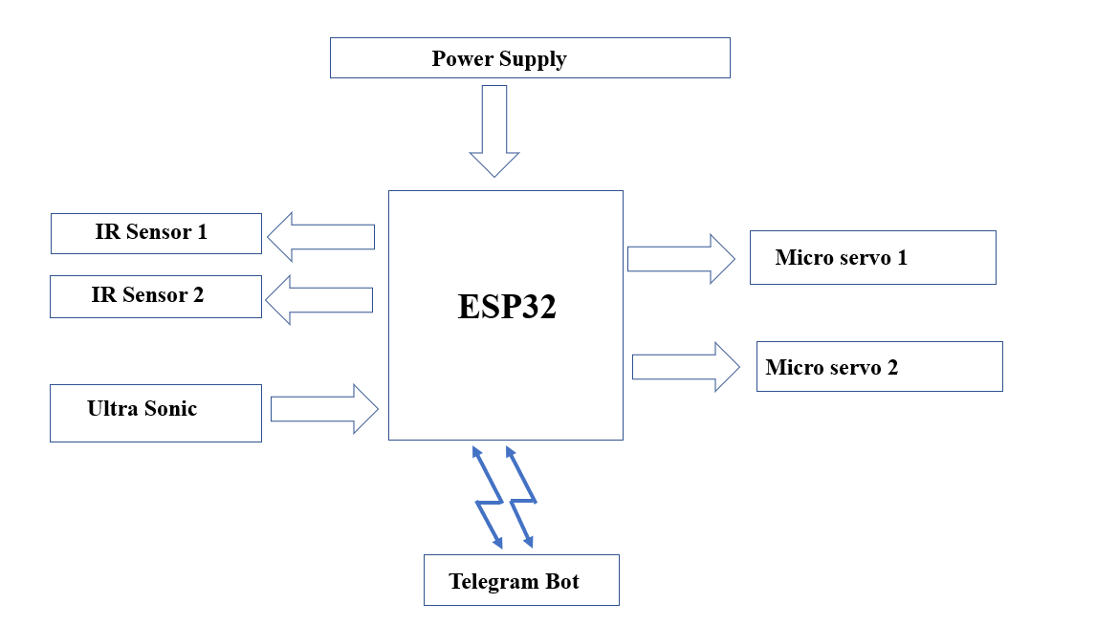

# HARDWARE AND SOFTWARE TOOLS

* 1. **Arduino IDE:**

Arduino is a both an open source software library and an open-source breakout board for the popular AVR micro-controllers. The **Arduino IDE** (Integrated Development Environment) is the program used to write code, and comes in the form of a downloadable file on the Arduino website. The Arduino board is the physical board that stores and performs the code uploaded to it. Both the software package and the board are referred to as "Arduino."

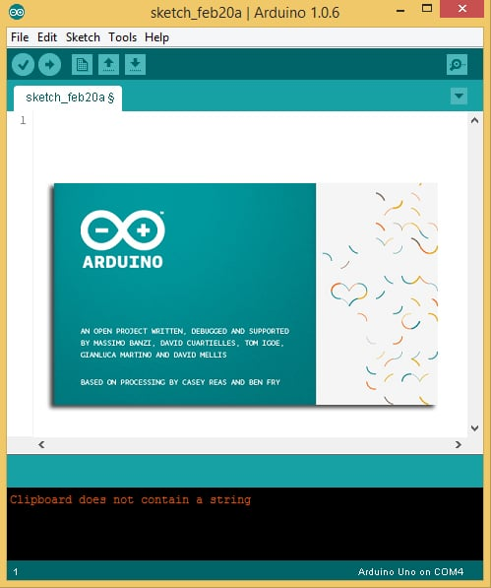

Arduino programs made in Arduino IDE are known as sketches. So if we talk about the structure of basic Arduino sketch, then we can say that it consists of two mandatory functions known as setup () and loop () functions. Whenever we open a new window in ArduinoIDE we can see that these two functions are already present in new sketch. So let’s talk about the basic necessities of functions and will explain it using hello world problem as a tradition to introduce beginners with programming.

* 1. **ESP 32:**

ESP32 is a development board. That means it has all the features you need to create projects. ESP32 is far superior than [Arduino UNO](https://www.circuitschools.com/what-is-arduino-how-it-works-and-what-you-can-do-with-arduino/) and an ESP8266, which does not mean that it is ideal for any project. ESP32 has an additional core compared to ESP8266, Faster Wi-Fi**,** increased number of GPIO (input/output) pins, Compatibility with Bluetooth 4.2 and Bluetooth low energy (*low energy*) Additionally, the **ESP32** comes with touch-sensitive pins that can be used to “wake up” the **ESP32** from deep sleep**mode**and a built-in Hall effect sensor.

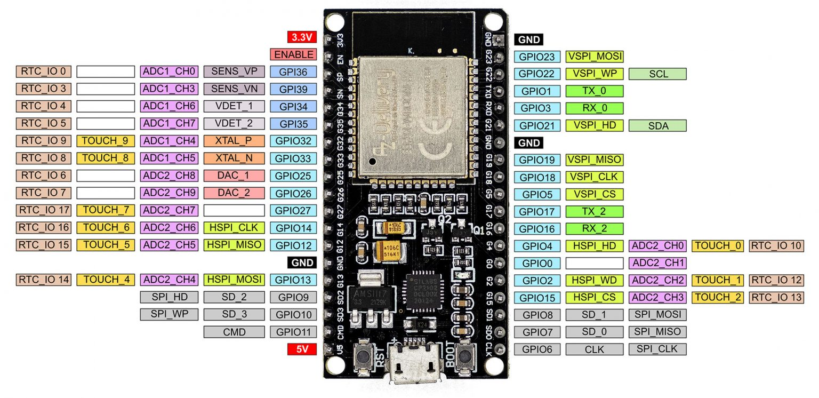

Different types of ESP32 microcontrollers have been manufactured and are available on the market. The one we have fully examined and explained in this tutorial is the ESP32-WROOM-32 microcontroller which is  also known as WROOM32. This microcontroller is one of the most famous and widely used microcontroller among all ESP32 series and is also used in a lot of ESP32-based development boards. These development boards include ESP32 Wemos Lolin32, ESP32-CoreBoard, and so on. Also, if you’re using a development board based on an ESP32 microcontroller other than WROOM32, this tutorial can still be useful for you, since other types of ESP32 microcontrollers come with pins similar to the WROOM pins.

* 1. **ULTRASONIC SENSOR:**

The ultrasonic sensor uses sonar to determine the distance to an object. Here’s how it works:

1. The ultrasound transmitter (trig pin) emits a high-frequency sound (40 kHz).
2. The sound travels through the air. If it finds an object, it bounces back to the module.
3. The ultrasound receiver (echo pin) receives the reflected sound (echo).

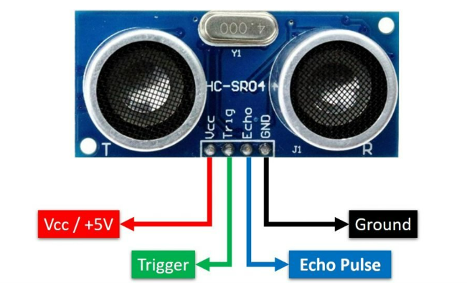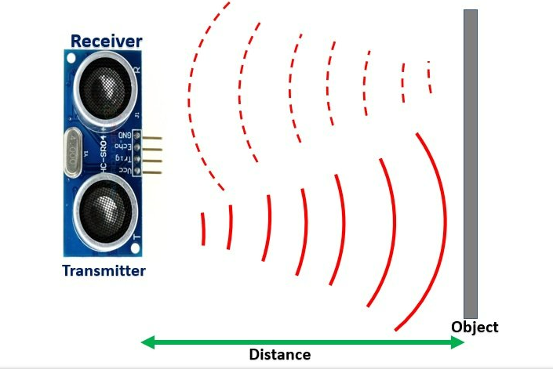

Distance (S) = Speed (v) * t  //distance in meters

Here v is the speed of ultrasonic waves in air. The speed of ultrasonic waves in air is equal to the speed of sound which is 340 m/s (meter per second).

The above equation will give distance output in units of meter. But, if you want the distance in centimeter units, multiply 340 with 100.  Hence, the above equation becomes:

S = 34000 * t // distance in cm

* 1. **IR SENSOR:**

IR sensor is an electronic device, that emits the light in order to sense some object of the surroundings. An [IR sensor](https://robu.in/product-category/sensor/ir-and-pir-sensor/) can measure the heat of an object as well as detects the motion. Usually, in the [**infrared spectrum**](https://en.wikipedia.org/wiki/Infrared_spectroscopy), all the objects radiate some form of thermal radiation. These types of radiations are invisible to our eyes, but infrared sensor can detect these radiations.

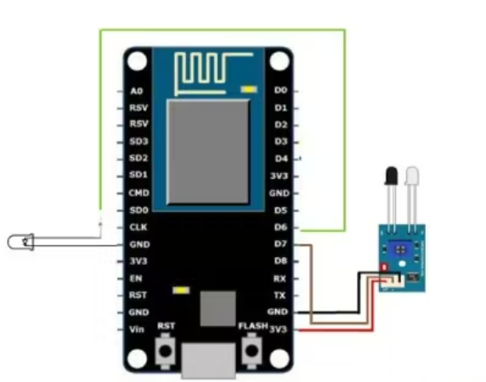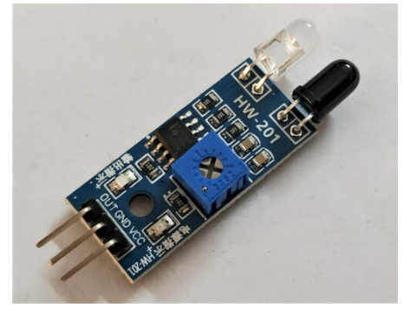

The emitter is simply an IR LED [(Light Emitting Diode](https://robu.in/product-category/display-boards/led/)) and the detector is simply an IR photodiode . Photodiode is sensitive to IR light of the same wavelength which is emitted by the IR LED. When IR light falls on the photodiode, the resistances and the output voltages will change in proportion to the magnitude of the IR light received.

There are five basic elements used in a typical infrared detection system: an infrared source, a transmission medium, optical component, infrared detectors or receivers and signal processing. Infrared lasers and Infrared LED’s of specific wavelength used as infrared sources.

The three main types of media used for infrared transmission are vacuum, atmosphere and optical fibers. Optical components are used to focus the infrared radiation or to limit the spectral response

* 1. **Micro Servo:**

Micro Servo Motor SG90 is a**tiny and lightweight server motor with high output power**. Servo can rotate approximately 180 degrees (90 in each direction), and works just like the standard kinds but smaller. You can use any servo code, hardware or library to control these servos.

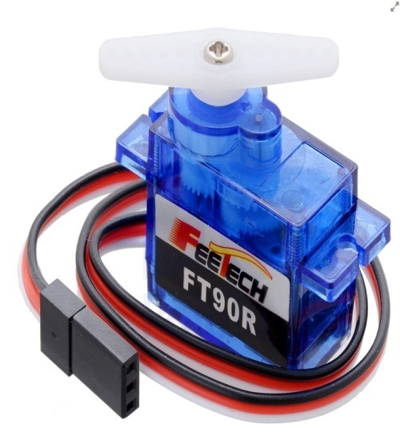

There are lots of **servo motors** available in the market and each one has its own speciality and applications. The following two paragraphs will help you identify the right type of servo motor for your project/system.

Most of the hobby Servo motors operates from 4.8V to 6.5V, the higher the voltage higher the torque we can achieve, but most commonly they are operated at +5V.  Almost all hobby servo motors can rotate only from 0° to 180° due to their gear arrangement so make sure your project can live with the half circle. If no, you can prefer for a 0° to 360° motor or modify the motor to make a full circle. The gears in the motors are easily subjected to wear and tear, so if your application requires stronger and long running motors you can go with **metal gears** or just stick with normal plastic gear.

* 1. **Telegram Bot:**

Telegram Messenger is a cloud-based instant messaging and voice over IP service. You can easily install it on your smartphone (Android and iPhone) or computer (PC, Mac, and Linux). It is free and without any ads. Telegram allows you to create bots that you can interact

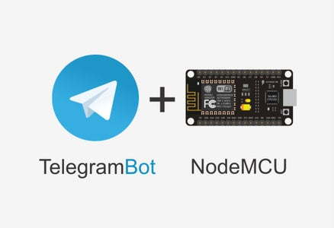

To interact with the Telegram bot, we’ll use the [Universal Telegram Bot Library](https://github.com/witnessmenow/Universal-Arduino-Telegram-Bot) created by Brian Lough that provides an easy interface for the Telegram Bot API.

Follow the next steps to install the latest release of the library.

1. [Click here to download the Universal Arduino Telegram Bot library](https://github.com/witnessmenow/Universal-Arduino-Telegram-Bot/archive/master.zip).
2. Go to **Sketch**> **Include Library**> **Add.ZIP Library..**.
3. Add the library you’ve just downloaded.

don’t install the library through the Arduino Library Manager because it might install a deprecated version

# IMPLEMENTATION

# The sensors IR ,Ultra sonic and Actuator Micro servo are connected to ESP32 digital pins. Now the ESP32 is connected with telegram bot with the help of wifi.

# An Ultra sonic sensor is in active mode all the time to detect the motion of the car coming near to it. Whenever the change is noticed by ultrasonic sensor from a give distance it immediately send the message as “Car has arrived” and ask the password to enter. Whenever the user enter the correct or defined password the micro servos/garage door will be opened for few minutes. After the certain period the door will be close automatically.

# The total setup of circuit is on bread board we are connecting the sensors to ESP32 with the help of connecting wires. After entering the password the password will be sent to Esp32 microcontroller. ESP 32 will verify the entered password with the redefined password. If password is same then it allows the micro servo to open the garage door.

# RESULT

In this project, we are going to monitor the status of a door using an ESP32 board we will receive a message in your Telegram account whenever the garage door changes state: opened or closed and car arrival status.As long as you have access to the internet on your smartphone, you’ll be notified no matter where you are. The ESP32 board will be programmed using Arduino IDE.In this [password based garage door locking system project](https://www.elprocus.com/advanced-microcontroller-based-mini-projects-for-engineering-students/), the micro controller is connected telegram bot the message from telegram are used to open and close the door. After entering a password, if it matches with the stored one, then the door will unlock for a limited period of time. After extending the unlocking process for a fixed period of time, the relay energizes, and then the door gets locked again. If any unauthorized person enters a wrong password in an attempt to open the door, then this system [does](https://www.elprocus.com/8-candidate-quiz-buzzer-circuit-using-8051-microcontroller/) not allow that person to open the door.

# CONCLUSION

The main objective of this project is to unlock a garage door by an android application using a unique password entered through the android application device. Opening and closing of garage door involves human labor. In this proposed system, the opening and closing of a garage door is achieved by using an android application. The owner can enter the password as a simple message, which in turn is connected to a microcontroller controlled garage door that can open/close the door by entering the password. This method is very convenient as one doesn’t have to get down of his car to open/close the door physically.

Remote operation is achieved by any smart-phone/Tablet etc., with Android OS, upon a telegram Bot based password operation. This project is based on the android application, android application send data through wifi. Another wifi device connected at the receiving end which is fed to the microcontroller. The sent data (password entered by the user) matches with the password stored in the microcontroller, and then the microcontroller initiates a mechanism to open the door through a motor driver interface.

# REFERENCES

1. Bórquez López, R.A.; Martinez Cordova, L.R.; Gil Nuñez, J.C.; Gonzalez Galaviz, J.R.; Ibarra Gamez, J.C.; Casillas Hernandez, R. Implementation and evaluation of open-source hardware to monitor water quality in precision aquaculture. *Sensors***2020,** 20, 6112.
2. Salim, T.I.; Haiyunnisa, T.; Alam, H.S. Design and implementation of water quality monitoring for eel fish aquaculture. In Proceedings of the International Symposium on Electronics and Smart Devices (ISESD), IEEE, November 2016.
3. Khatri, P.; Gupta, K.K.; Gupta, R.K. Smart Water Quality Monitoring System for Distribution Networks. In proceedings of International Conference on Sustainable Computing in Science, Technology and Management (SUSCOM), Amity University Rajasthan, Jaipur-India, February 2019.

[4] [ESP32 Door Status Monitor Telegram Notifications | Random Nerd Tutorials](https://randomnerdtutorials.com/esp32-door-status-telegram/)

[5] [Password Based Intelligent Electronic Lock System (elprocus.com)](https://www.elprocus.com/password-based-electronic-lock-system/)

[6] https://youtu.be/5hyflMni6HM